How to host website in EC2

Steps:

1. Choose your region
2. Create security group and open ports 80 and 22
3. Launch an EC2 instance(add the security group and key pair)
4. SSH into EC2 instance
5. Install the software that your website needs
6. Put the web files into HTML directory.

Choose your region

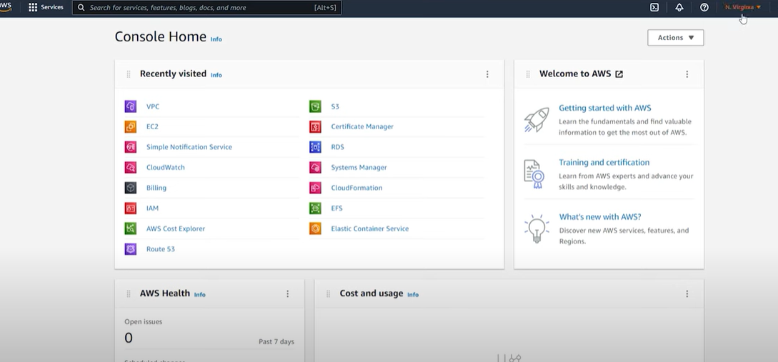

2) Create security group and open ports 80 and 22

Search VPC

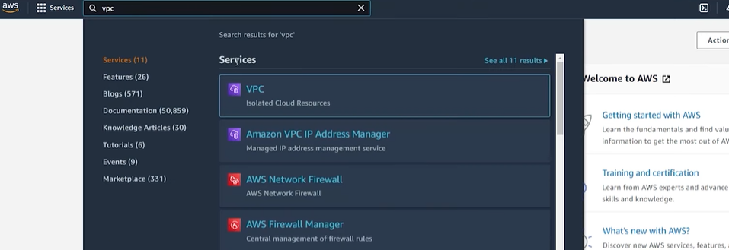

Select Security

Under security select security group

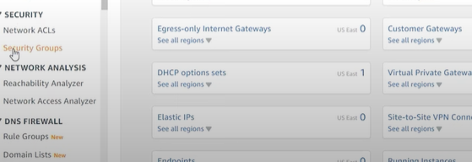

Create security group

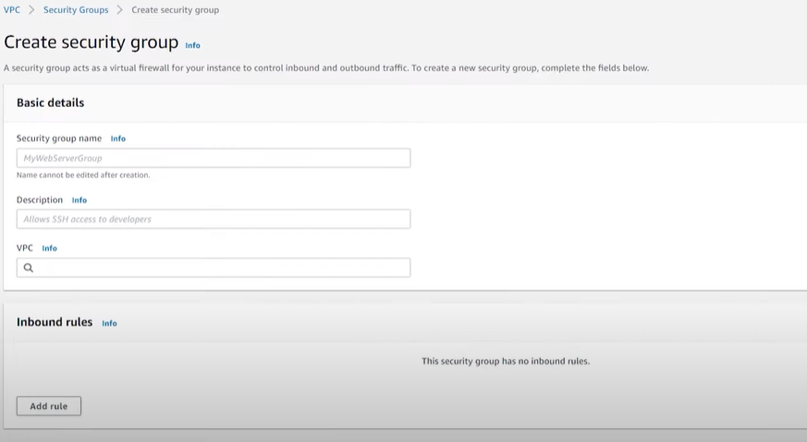

Enter security group na me

Description

Desfault VPC

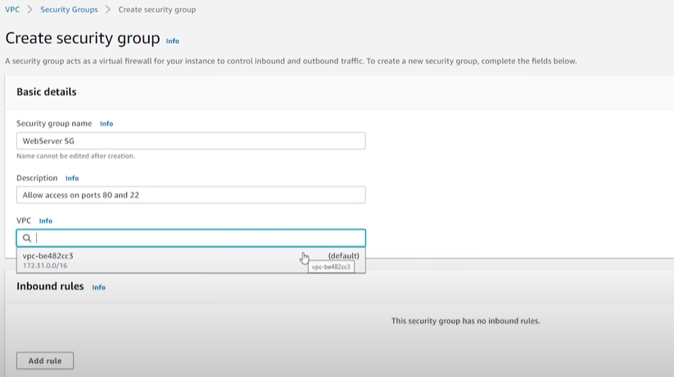

Click on add rule

Add same thing as image

HTTP TCP 80 ANYWHERE IPV4 0.0.0.0/0

ADD RULE

SSH TCP 22 MYIP 108(SAME AS IMAGE)

Click on create security group on down

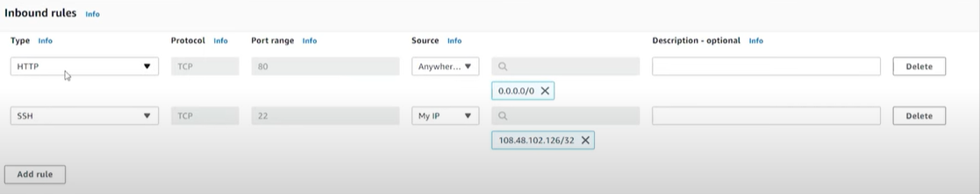

3) Launch an Instance

select EC2 instance

EC 2 dashboard

Launch instance

Give Name of instance

Application and OS image

Select quick start and select Amazon linux 2 AMI machine(SEE BELOW DIAGRAM)

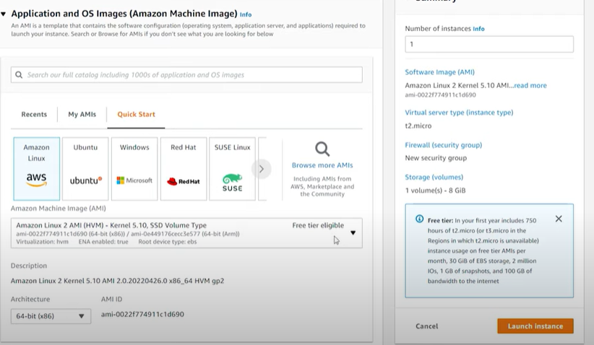

Check instance type t2.micro

Select key pair

Scroll down

In network setting edit

Select default VPC

Select any subnet to launch your instance

Scroll down

Select security group- select existing security group

Select created security group in VPC(common security group)

Click launch instance

Click view all instance

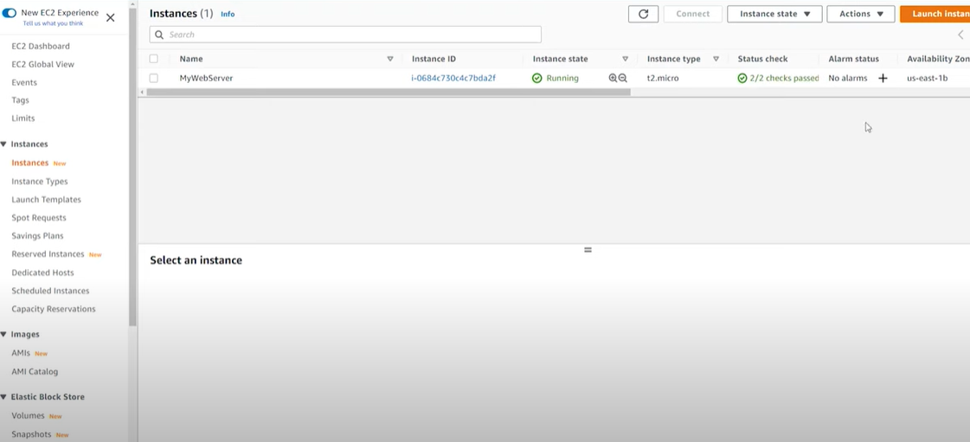

Click on refresh and check in status check if check has passed.(check arrow)

4) SSH into the ec2 instance

Check on EC2 instance and go to details

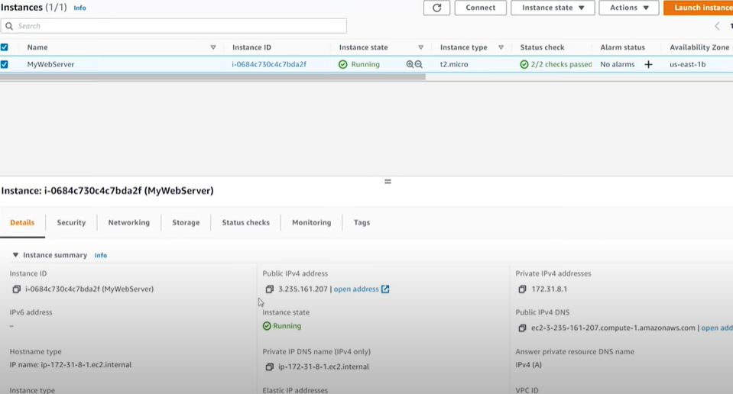

Copy public ipv4 address

After open putty

Enter session

And enter

ec2-user@ copied public ip address

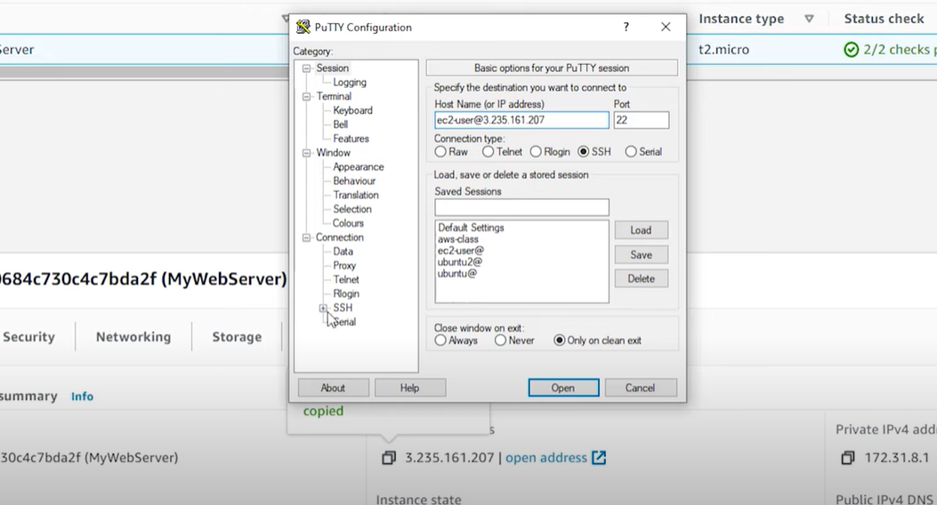

Select SSH

Click on auth word

Select browse and open key pair(select it)

And click on open and yes

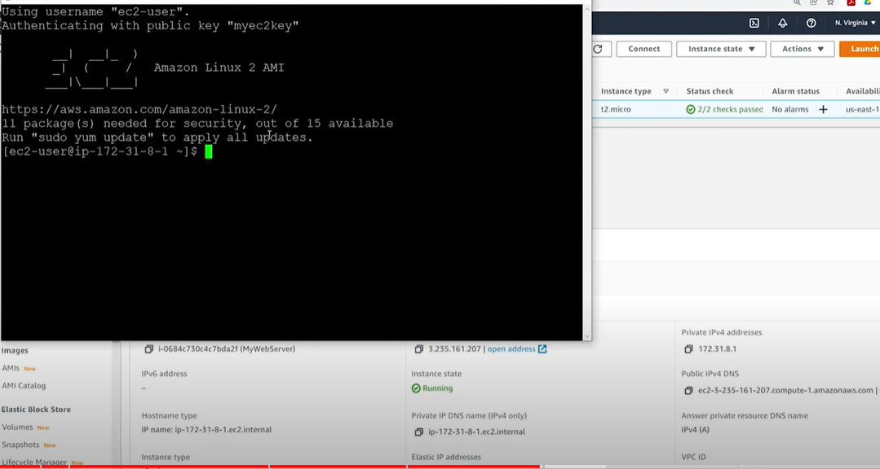

5) Install the software your website needs

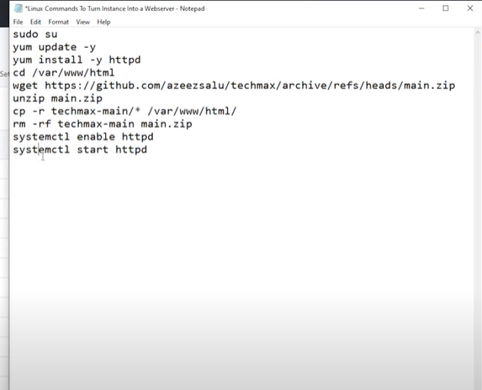

Type one by one command

1. Sudo su(allow EC2 instance
2. Yum update –y ( for security policies)
3. After it will get complete
4. Yum install –y htttpd (download apache to EC2 instance) (it will get complete meassge on command prompt)
5. cd /var/www/html

cd is change directory(so change directory to HTML directory)

1. wget (path you have to mention.zip) (website HTML path)
2. unzip main(directory name)
3. unzip.directory name.zip
4. elnter ls command(it will show you list )

6) Put website to HTML directory

1) cp –r directory name /\* /var/www/html

For e.g. cp –r techmax.main/\* /var/www/html

2) rm –rf techmax-main main.zip

3) type ls(list command) and see what happened??

7) Start Apache service

Type systemctl enable httpd

Systemctl start httpd

After that go to instance select public ip address go to new tab and paste over there and it will host your website

7) Terminate Ee2 instance(MOST IMPORTANT)